

**LITHIUMMOTO CART BATTERY MODULES**

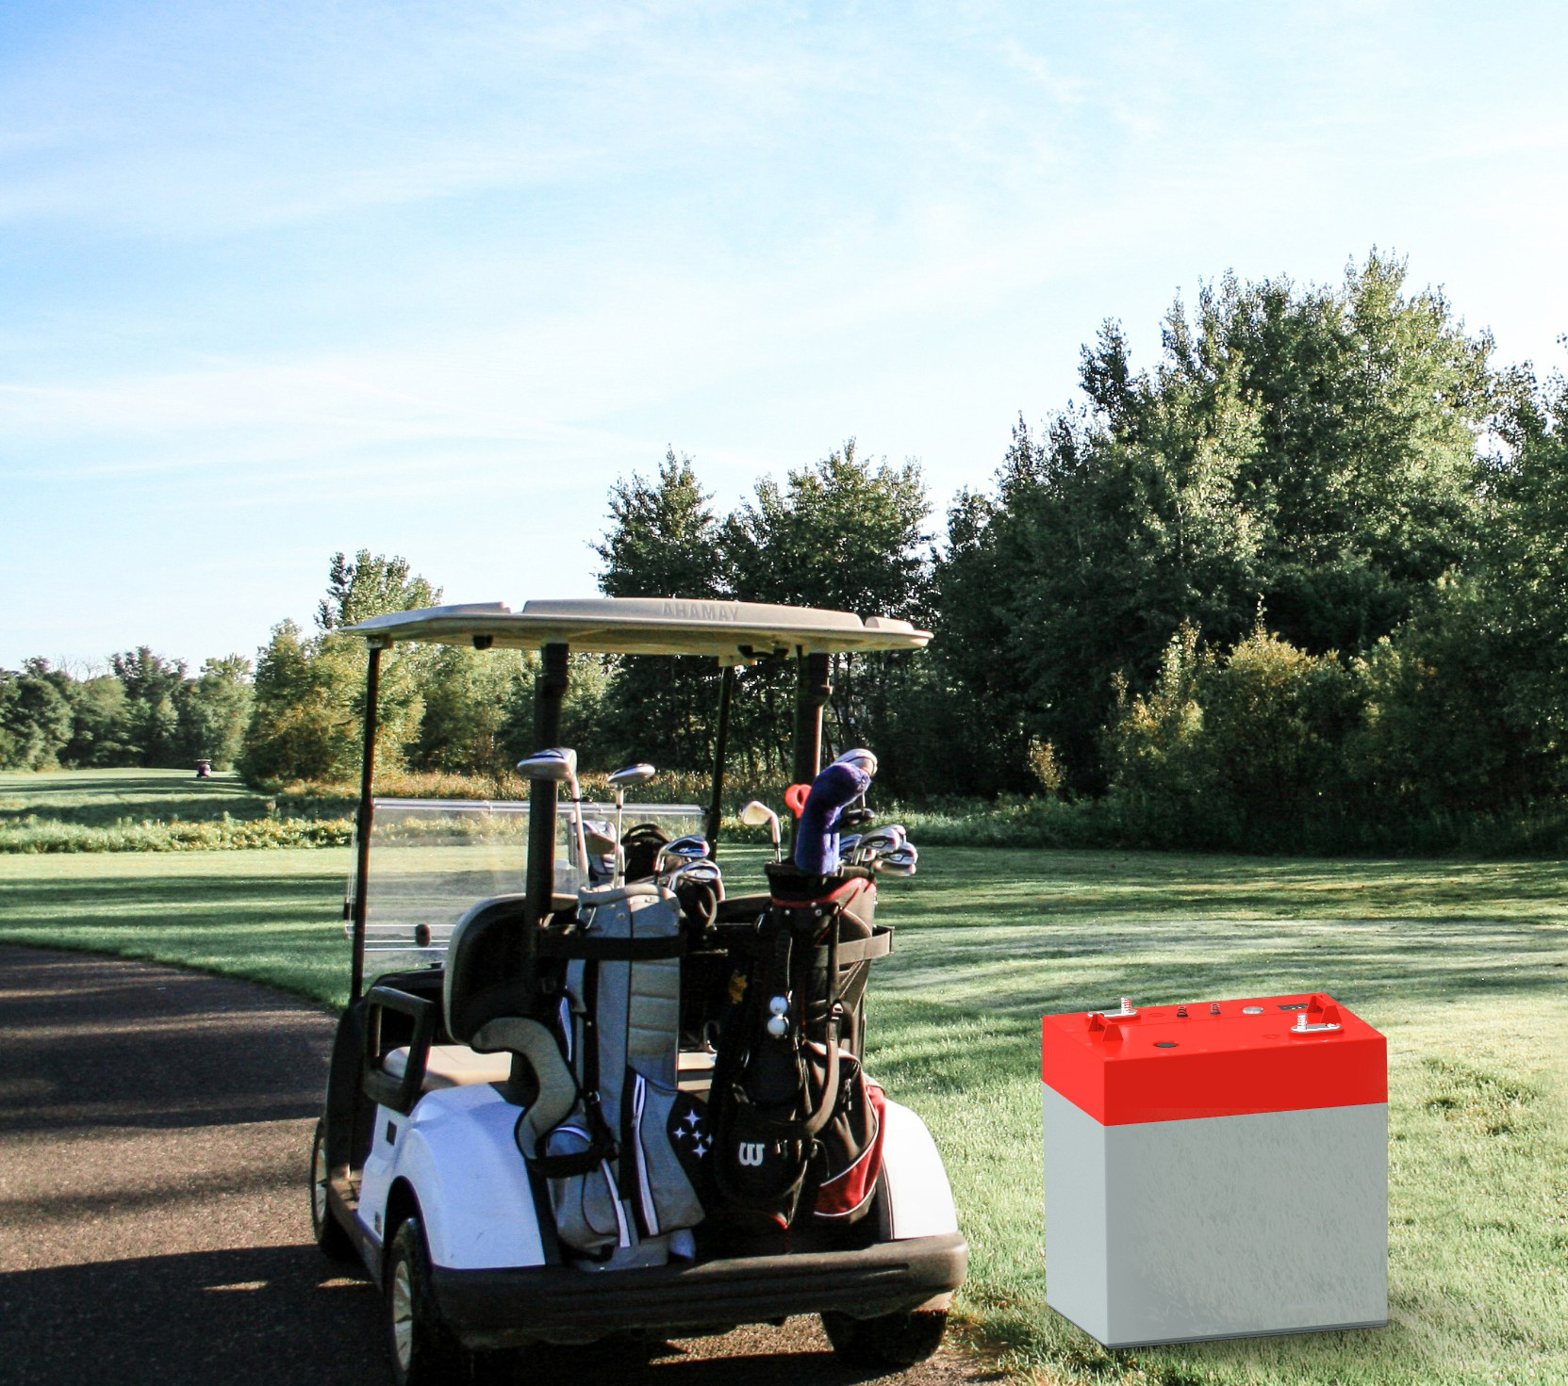

Golf Cart Battery

Constant Power With Long Lasting Lithium

LithiumMoto specializes in developing golf cart lithium iron phosphate batteries to replace ancient lead acid.

They are extensively used in Golf Car, Utility Vehicle, PTV, AGV, Marine, etc. due to its superior performances of high safety, ultra long life, higher energy density, longer lasting time, fast charging and eco-friendly.

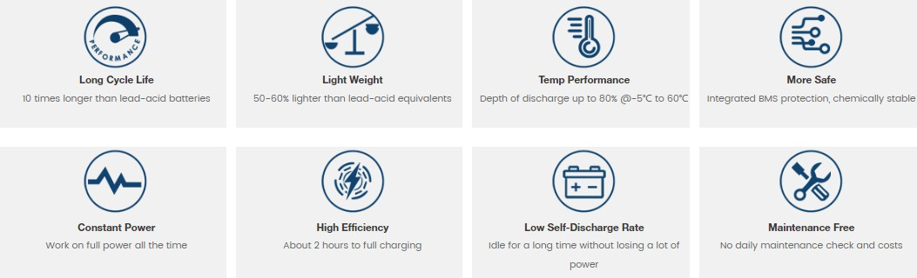

|  |  |  |  |  |
| --- | --- | --- | --- | --- |
|  | **LP51.2-32** | | | |
| FUNCTIONAL SPECIFICATIONS | | | | |
| Nominal Voltage |  | 51.2 V |  |  |
| Ampere-hour Capacity | 32 Ah | | | |
| Watt-hours |  | 1.638KW | H |  |
| Specific Energy | 110Wh/kg | | | |
| Resistance @ 50% SOC |  | ≤30 mΩ |  |  |
| Charge Efficiency | 99% | | | |
| Cycle Life | 6000cycles (DOD80%) | | | |
| MECHANICAL SPECIFICATIONS |  | | | |
| BCI Size | GC2 / GC8 | | | |
| Dimensions (L x W x H) | 260 x 180 x 276mm(10.2” x7.1” x 10.9”） | | | |
| Weight |  | 15.6kg (34. | 3Ibs) |  |
| Case Material | ABS/FR | | | |
| Stud Terminal | M8 x 1.25 - 20 | | | |
| Insert Terminal | M8 x 1.25 - 20 | | | |
| Torque | 79.7-88.5 in-Ibs. 6.6 -7.4 ft-Ibs 9-10 N-m | | | |
| Handles | Molded | | | |
| Enclosure Protection | IP67 | | | |
| Case Flame Rating | UL94-V0 | | | |
| DISCHARGE SPECIFICATIONS |  | | | |
| Continuous Discharge Current | 100A | | | |
| Peak Discharge Current | 200A - 10 sec | | | |
| Short Circuit Protection | 580A - 256 usec | | | |
| Protection Recover | Automatic | | | |
| Low Voltage Disconnect | 40.0V - 2 sec (2.5V/Cell) | | | |
| Low Voltage Reconnect | Automatic | | | |
| Self-Discharge @25ºC in Off mode | <3% per Month | | | |
| CHARGE SPECIFICATIONS |  | | | |
| Max. Continuous Charge Current | 30A @ 25ºC | | | |
| Disconnect Charge Current | 65A - 6 sec | | | |
| Recommended Charge Voltage | 55.2V max | | | |
| Float Voltage | 54.4V | | | |
| High Voltage Disconnect | 59.2V - 2 sec (3.7V/Cell) | | | |
| High Voltage Recoonect | Automatic | | | |
| Temperature Compensation | None | | | |
| ENVIRONMENTAL SPECIFICATIONS |  | | | |
| Recommended Charge Temperature | 32 ~ 113 ºF (0 ~ 45 ºC) | | | |
| Recommended Discharge Temperature | -4 ~ 140 ºF (-20 ~ 60 ºC | | | |
| High Temperature (charge) Protection | 131°F (55ºC) | | | |
| Low Temperature (charge) Protection | 32 ºF (0 ºC) | | | |
| High Temperature (discharge) Protection | 149°F (65ºC) | | | |
| Low Temperature (discharge) Protection | -22°F (-30ºC) | | | |
| Operating Humidity Storage Temperature | <90% RH -4°F to 95°F (-20°C to 35°C) | | | |
| Storage Humidity | 25 ~ 85% RH | | | |
| COMPLIANCE |  | | | |
| CERTIFICATIONS &STANDARD | CE (battery),UN38.3 (battery),UL2271 & IEC62133 | | | |
| Shipping Classification | UN 3480, CLASS 9 | | | |

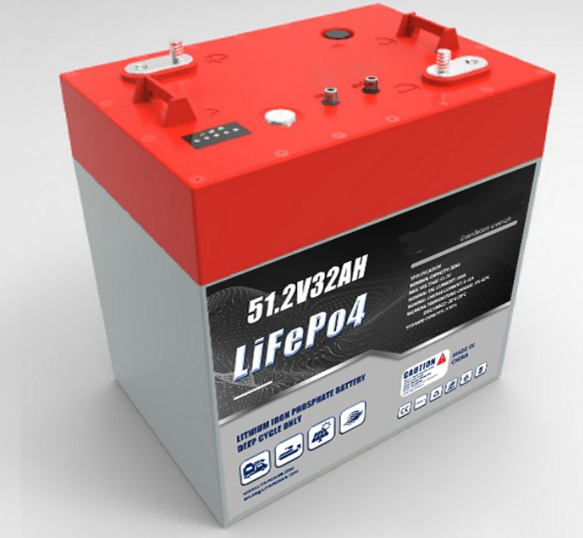

# LITHIUM IRON PHOSPHATE BATTERY

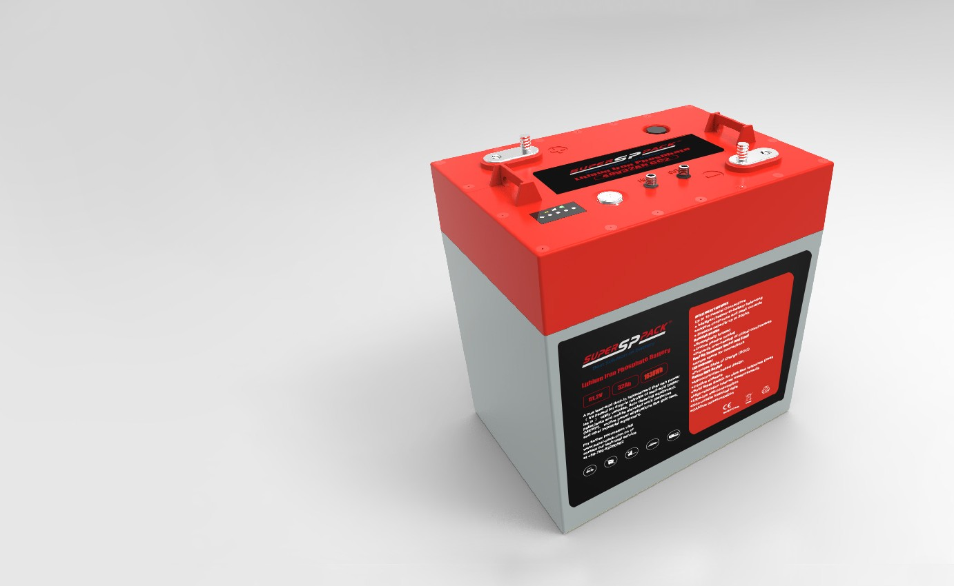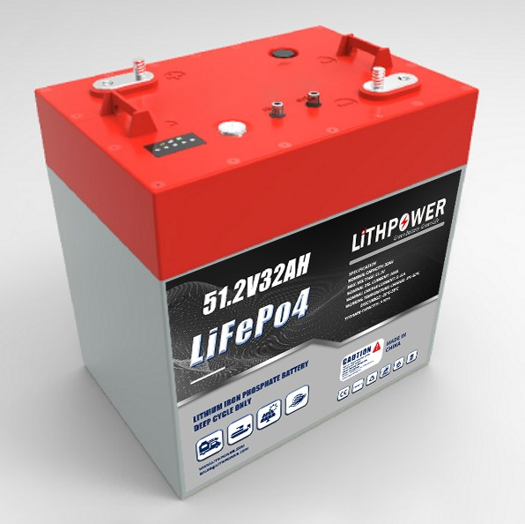

INTELLIGENT FEATURES

Up to 10 Parallel Connections

Intelligent battery-to-battery balancing

Additive continuous and peak currents

Scalable capacity up to 300Ah

Heatsink Design

Strategically located

Unique passive cooling

•Prevents over-heating of critical components

Dual M8 Terminals (insert and Stud)

Ample space for connections

LED Indicator

Provides State of Charge (SOC)

Unique BMS Design

Microcontroller-based design

Intuitive software

Solid State Switch for ultra-fast response times

High-resolution internal measurements

Ultra-low self-consumption

Non-volatile historical data

CANbus communication

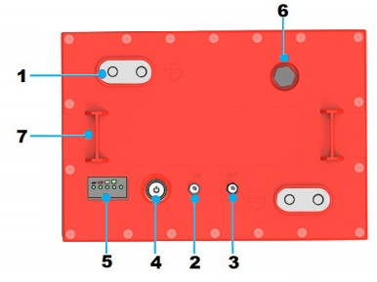

1. Dual M8 Terminals (insert & stud)
2. CANbus Input
3. CANbus Output
4. Power Button
5. SOC/Status LEDs
6. Vent
7. Lifting Brackets



# BATTERY DIMENSIONS

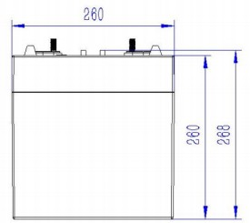

Front View

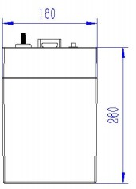

Side View

Perormance may vary depending on application All specifications are subject to change without prior notice to the user. This data is for

evaluation purposes only.No guarantee is intended or implied by this data. For clarification and updated information,please contact us.