X`
LithiumMoto Catalog
Ⅰ. Charger series LEAD ACID AND LITHIUM

On Board Chargers/Portable Chargers
Input Voltge |  | AC 220v ± 15% (only)
Configuration |  | On-board charger standard ：  - Input plug  - Output connector  - Charging indicator(Built -in or External)  - Handle  - Auxiliary power 12v 3a/5a (optional) 12v 3a/5a
Model  LithiumMoto | Rated Voltage  （V) | Max Output Current  (A) | Size (mm) |  |  | Weight (kg) | Pictures
Model  LithiumMoto | Rated Voltage  （V) | Max Output Current  (A) | L | W | H | Weight (kg) | Pictures
LithiumMoto  2000w  Input ≤12.5A | 12/24 | 40 | 280 | 155 | 115 | 4.5 | 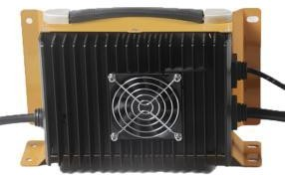
LithiumMoto  2000w  Input ≤12.5A | 36/48/60 | 30
LithiumMoto  2000w  Input ≤12.5A | 72 | 25
LithiumMoto  2000w  Input ≤12.5A | 80/84 | 20
LithiumMoto  2000w  Input ≤12.5A | 96/108 | 18
LithiumMoto  2000w  Input ≤12.5A | 24 | 40 | 288 | 162 | 94 | 4.5 | 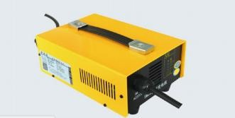
LithiumMoto  2000w  Input ≤12.5A | 36 | 30
LithiumMoto  2000w  Input ≤12.5A | 48 | 35
LithiumMoto  2000w  Input ≤12.5A | 60 | 30
LithiumMoto  2000w  Input ≤12.5A | 72 | 30
LithiumMoto  2000w  Input ≤12.5A | 84 | 18
LithiumMoto  2000w  Input ≤12.5A | 96 | 15

Input Voltge |  | AC 90V-264V
Configuration |  | On-board / portable charger standard ：  - Input plug 2. Output connector 3. Handle 4. Waterproof  5. Charge status indicator(Built -in or External)  6. Auxiliary power 12v 3a/5a (optional) 12v 3a/5a  Three year limited warranty  These are all high frequency switch mode type chargers
Model  LithiumMoto | Rated Voltage  （V) | Max charging Voltage (V) | Max output Current |  | Size (mm) |  |  | Weight (kg) | Pictures
Model  LithiumMoto | Rated Voltage  （V) | Max charging Voltage (V) | 220v AC | 110v AC | L | W | H | Weight (kg) | Pictures
LithiumMoto  480W  Input ≤3A | 12 | 15 | 15 |  | 183 | 106 | 69 | 1.7 | 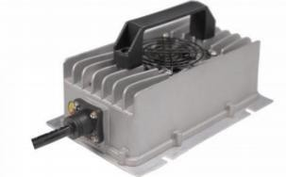
LithiumMoto  480W  Input ≤3A | 24 | 30 | 15
LithiumMoto  600W  Input ≤3A | 12 | 15 | 30 |  | 193 | 124 | 67 | 1.8
LithiumMoto  600W  Input ≤3A | 24 | 30 | 20 | 15
LithiumMoto  600W  Input ≤3A | 36 | 45 | 12 | 8
LithiumMoto  600W  Input ≤3A | 48 | 60 | 10 | 6
OneE-ES- 800W  Input ≤6A | 24 | 30 | 15 | 10 | 190 | 140 | 74.5 | 2 | 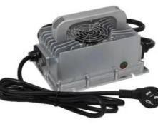
OneE-ES- 800W  Input ≤6A | 36 | 45 | 15 | 15
OneE-ES- 800W  Input ≤6A | 48 | 60 | 15 | 12
OneE-ES- 800W  Input ≤6A | 60 | 75 | 12 | 8
OneE-ES- 800W  Input ≤6A | 72 | 90 | 10 | 6

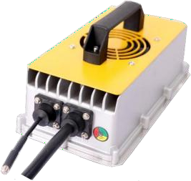
Model  LithiumMoto | Rated Voltage  （V) | Max charging Voltage (V) | Max output Current |  | Size  (mm) |  |  | Weight (kg) | Pictures
Model  LithiumMoto | Rated Voltage  （V) | Max charging Voltage (V) | 220v AC | 110v AC | L | W | H | Weight (kg) | Pictures
LithiumMoto  1000W  Input ≤7.5A | 24 | 30 | 25 | 20 | 232 | 127 | 112 | 2.5
LithiumMoto  1000W  Input ≤7.5A | 36 | 48 | 20 | 15
LithiumMoto  1000W  Input ≤7.5A | 48 | 68 | 15 | 15
LithiumMoto  1000W  Input ≤7.5A | 60 | 85 | 15 | 12
LithiumMoto  1000W  Input ≤7.5A | 72 | 102 | 10 | 8
LithiumMoto  1500w  Input ≤11A | 12 | 15 | 30 | 30 | 282 | 146 | 82 | 3 | 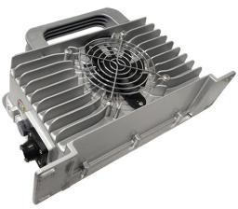
LithiumMoto  1500w  Input ≤11A | 24 | 30 | 30 | 30
LithiumMoto  1500w  Input ≤11A | 36 | 45 | 25 | 25
LithiumMoto  1500w  Input ≤11A | 48 | 60 | 25 | 20
LithiumMoto  1500w  Input ≤11A | 60 | 75 | 20 | 15
LithiumMoto  1500w  Input ≤11A | 72 | 90 | 18 | 12
LithiumMoto  1500w  Input ≤11A | 96 | 120 | 10
LithiumMoto  2000w  Input ≤13A | 24 | 30 | 40 | 40 | 282  282 | 168  168 | 90  90 | 3.8  3.8 | 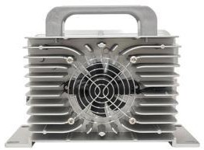  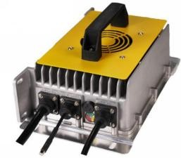
LithiumMoto  2000w  Input ≤13A | 36 | 45 | 40 | 30
LithiumMoto  2000w  Input ≤13A | 48 | 60 | 35 | 25
LithiumMoto  2000w  Input ≤13A | 60 | 75 | 30 | 20
LithiumMoto  2000w  Input ≤13A | 72 | 90 | 25 | 15
LithiumMoto  2000w  Input ≤13A | 80 | 100 | 22
LithiumMoto  2000w  Input ≤13A | 96 | 120 | 18 | 10
LithiumMoto
2000w

Input ≤13A
LithiumMoto  2000w  Input ≤13A | 48 | 60 | 35 | 25
LithiumMoto  2000w  Input ≤13A | 60 | 75 | 30 | 20
LithiumMoto  2000w  Input ≤13A | 72 | 90 | 25 | 15
LithiumMoto  2000w  Input ≤13A | 80 | 100 | 22
LithiumMoto  2000w  Input ≤13A | 96 | 120 | 18 | 10
LithiumMoto
On Board Chargers/PortableChargers
Contact: Andy Harris
Email: lithiummotobattery@gmail.com
Address:12031 Colwick St. San Antonio TX 78216
AC connector:
Intl. plugs available
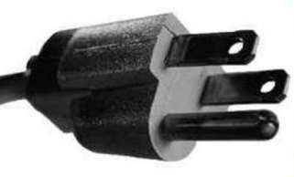

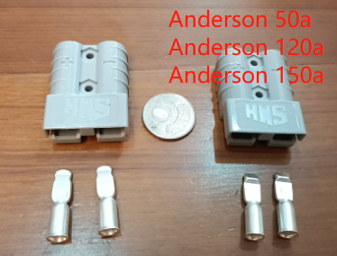
DC Connector Options :

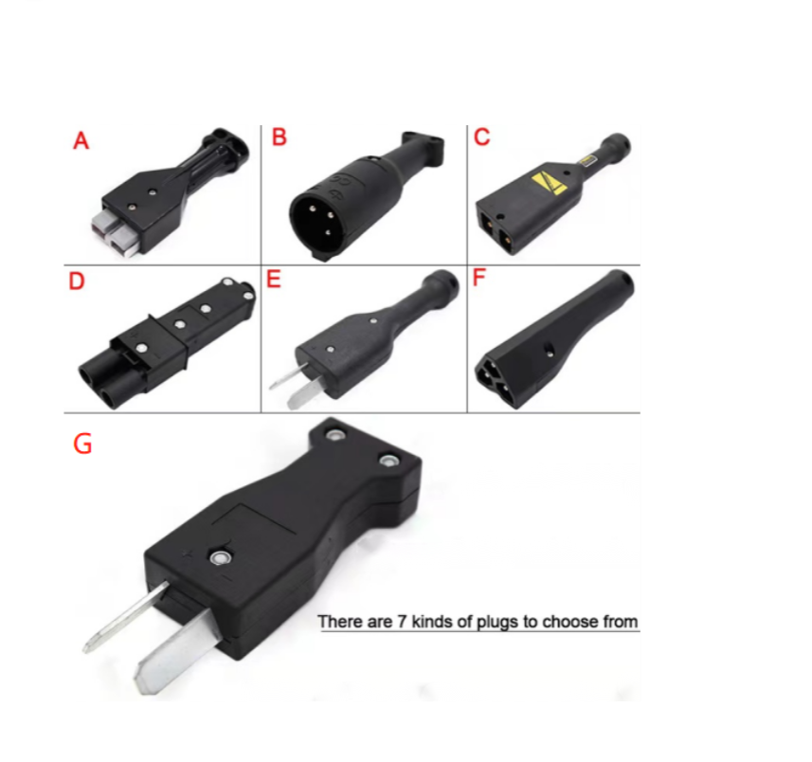

Model  LithiumMoto | Rated Voltage  （V) | Max charging Voltage (V) | Max output Current |  | Size  (mm) |  |  | Weight (kg) | Pictures
Model  LithiumMoto | Rated Voltage  （V) | Max charging Voltage (V) | 220v AC | 110v AC | L | W | H | Weight (kg) | Pictures
LithiumMoto  3000w  Input ≤15A | 24 | 30 | 50 | 25 | 315 | 198 | 114 | 8 | 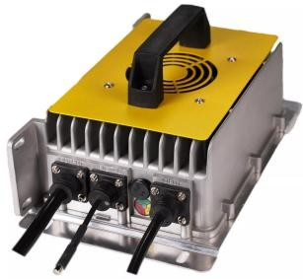
LithiumMoto  3000w  Input ≤15A | 36 | 49 | 50 | 25
LithiumMoto  3000w  Input ≤15A | 48 | 66 | 50 | 25
LithiumMoto  3000w  Input ≤15A | 60 | 85 | 35 | 17
LithiumMoto  3000w  Input ≤15A | 72 | 99 | 30 | 15
LithiumMoto  3000w  Input ≤15A | 96 | 115 | 30
LithiumMoto  3000w  Input ≤15A | 108 | 128 | 28
LithiumMoto  3000w  Input ≤15A | 144 | 180 | 20
LithiumMoto  3300w  Input ≤16A | 48 | 66 | 42 | 21 | 294 | 210 | 111 | 6 | 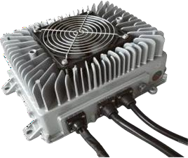
LithiumMoto  3300w  Input ≤16A | 60 | 82.5 | 40 | 20
LithiumMoto  3300w  Input ≤16A | 72 | 99 | 40 | 20
LithiumMoto  3300w  Input ≤16A | 84 | 116 | 40 | 20
LithiumMoto  3300w  Input ≤16A | 96 | 132 | 32 | 16
LithiumMoto  3300w  Input ≤16A | 120 | 144 | 25 | 12
LithiumMoto  3300w  Input ≤16A | 144 | 168 | 23 | 11
LithiumMoto  3300w  Input ≤16A | 160 | 198 | 15 | 7
LithiumMoto  3300w  Input ≤16A | 312 | 440 | 10 | 5
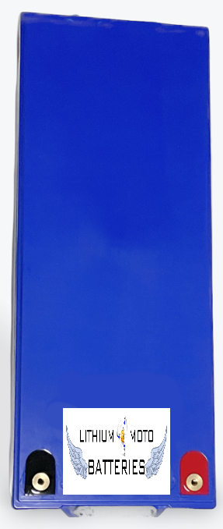
Lithium Performance UBER Lightweight
Battery;
48/53V, 130Ah, 76 lbs !
500A Peak discharge, 200A continuous
with Bluetooth
24 x 9.5 x 8”
Other voltages / Ah available
Assembled in USA

EV Chargers
Input Voltge |  |  | AC 90V-264V
Model  LithiumMoto | Type | Power | Size (mm) |  |  | Weight (kg) | Pictures
Model  LithiumMoto | Type | Power | L | W | H | Weight (kg) | Pictures
LithiumMoto  Portable EV Charger | GB/T | 3.5kw/16A  7kw/32A  11kw/16A  22kw/32A | / | / | / | 3kg | 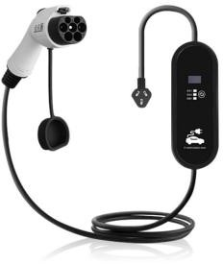
LithiumMoto  Portable EV Charger | SAE/ J1772/  Type1
LithiumMoto  Portable EV Charger | IEC/  Type2
LithiumMoto  EV Wallbox | GB/T | 3.5kw/16A  7kw/32A  11kw/16A  22kw/32A | 310 | 190 | 110 | 4kg | 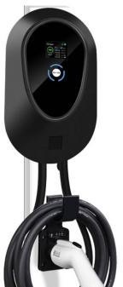
LithiumMoto  EV Wallbox | SAE/ J1772/  Type1
LithiumMoto  EV Wallbox | IEC/  Type2
LithiumMoto  EV Plug/socket  Extension Cable | GB/T | 16A  32A |  |  |  |  | 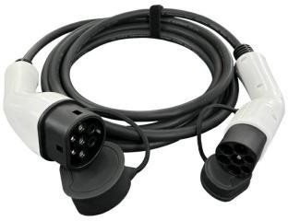
LithiumMoto  EV Plug/socket  Extension Cable | SAE/ J1772/  Type1
LithiumMoto  EV Plug/socket  Extension Cable | IEC/  Type2
EV Charger Accessories

OneE-EQ-A | SAE/Type1 pile to GB/T Car Type 1 to Type 2  Type 2 to GB/T | 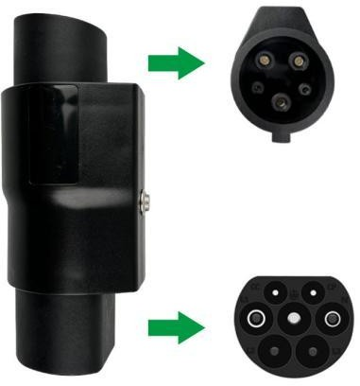
OneE-EQ-TP | Taking power from Pile SAE/J1772/Type1 Type2  GB/T
OneE-E1-TC | Taking power from Car SAE/J1772/Type1 Type2  GB/T | 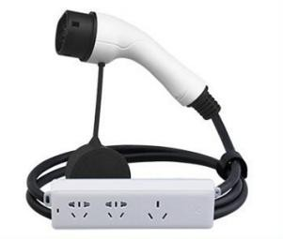
OneE-EQ-H | Plug holder | 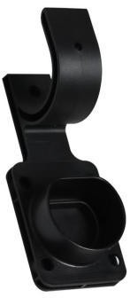
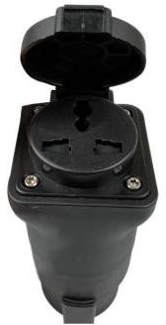
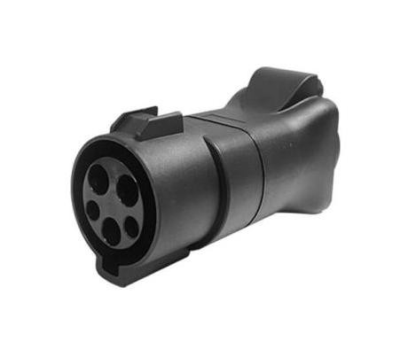

OneE-EQ-B | EV Charger Bag | 