
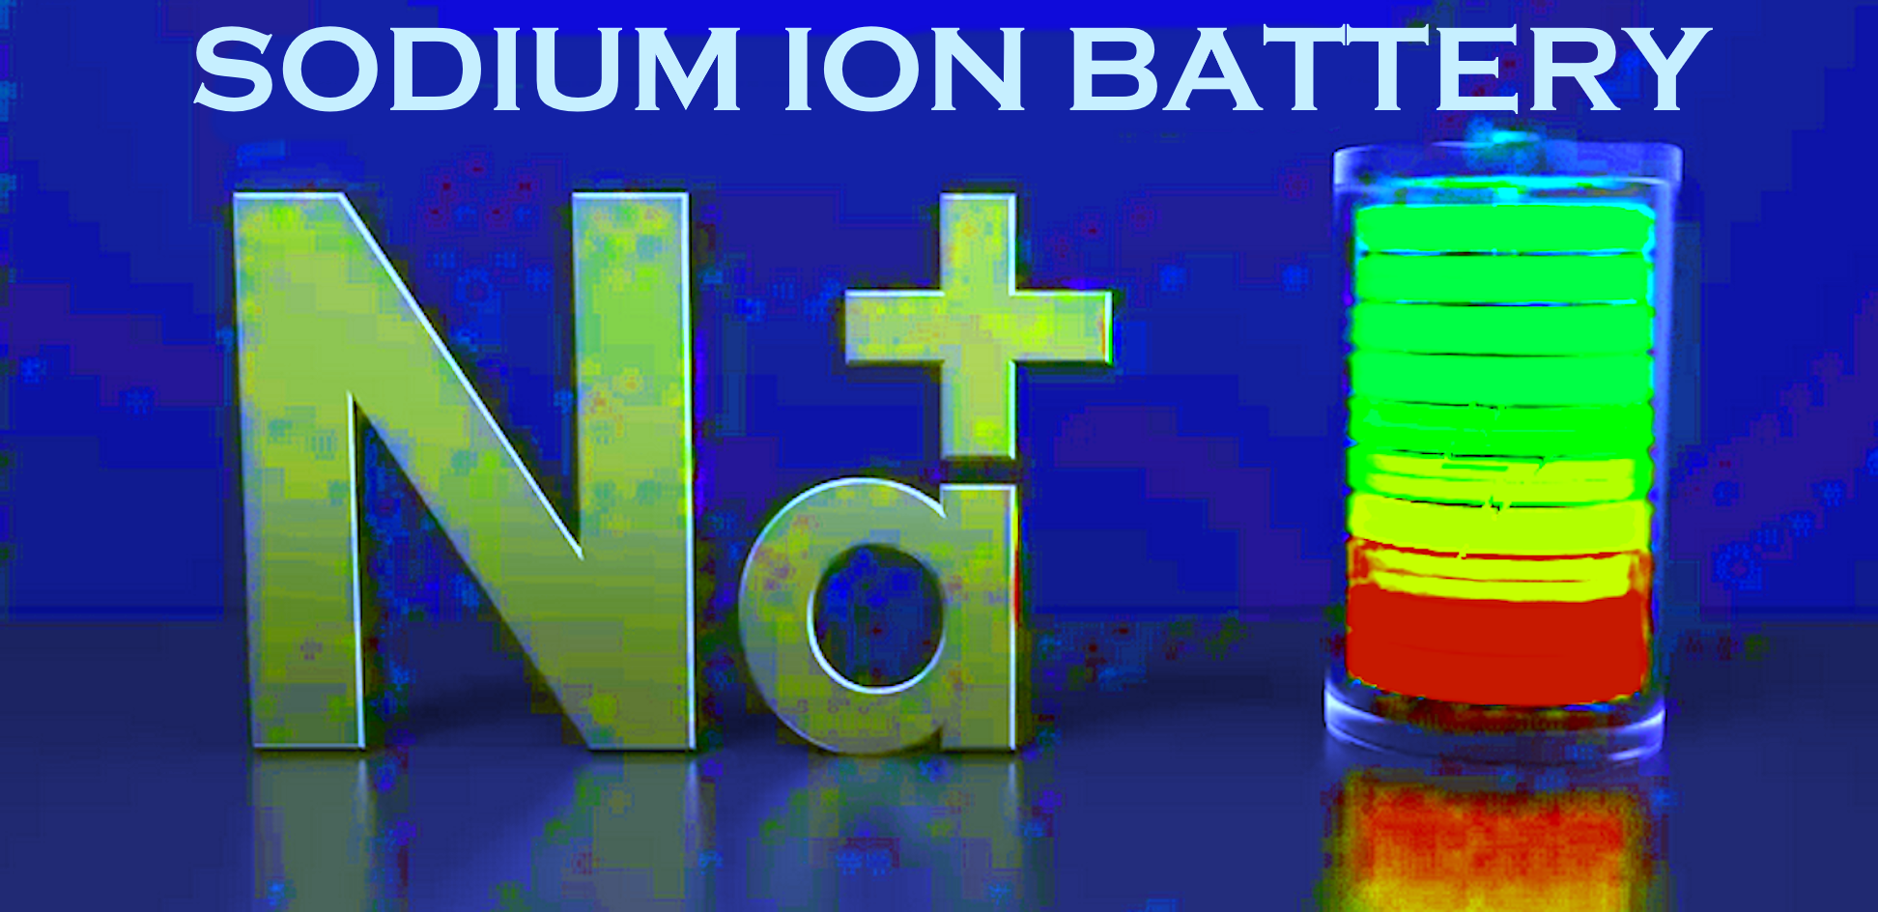

FEB 2024
After months of research and battery designs, LithiumMoto is now offering MARINE
SODIUM ion cell batteries for the replacement of lead acid AND Lithium batteries.
Here are the benefits compared to the leading lithium and lead acid batteries in the market.
SAFETY; Sodium has ZERO propensity for any exothermic reaction; no flame, no smoke, no
internal swelling of cells, no overheating or other issues that require a ‘ fault light ‘.
As safe as LiFepo4 may be, Sodium is even safer!
OPERATING TEMPS; Much wider range than lithium or lead. Not as sensitive to thermal issues like lithium and can accept lower charge/discharge temps than lead or lithium.
CHARGE: minus 10c/14f to 60c/140f DISCHARGE: minus 40cf to 100c/212f
OPERATING VOLTAGES: For 12v systems – 6 to 17volts – Can be discharged to zero volts
w/o any cell damage. No worries about a sudden cutoff from a “smart” BMS in a lithium battery. Cannot be overcharged or overdischarged from an aircraft system. No ‘ battery fault ‘
indicator required from a delicate lithium ‘smart’ battery that must be constantly monitored.
ENERGY DENSITY: Similar to LifePO4 and absolutely higher than lead. Good engine starting performance especially in extreme temps unlike lithium.
Voltage Discharge Curve; Linear downward, making SOH and SOC easier to determine with a simple voltage display.
CYCLE LIFE: Charge / discharge and overall lifespan; = or > LiFepo4 and much longer than lead.
WEIGHT: 20% heavier than LiFepo4 50% lighter than lead acid / AGM
Internal Resistance: higher than lifepo4, is less demanding of alternators, slower charge rate
than lithium, faster than lead acid.
ENVIRONMENTAL: MUCH friendlier and more sustainable than lead or lithium.
COST: Sodium cells are less costly to mfgr, raw material more abundant, almost 1/2 the cost of a comparable lithium battery and on par with AGM.

A Sodium battery, unlike a BMS controlled ‘ smart ‘ lithium battery can act as a voltage stabilizer and accept wide voltage variations and act as a buffer from the alternator similar to lead acid without fear of an unexpected BMS shutdown causing loss of all power to engine
There is no ‘ fault ‘ monitoring concerns because there are no fault weak points like lithium.
