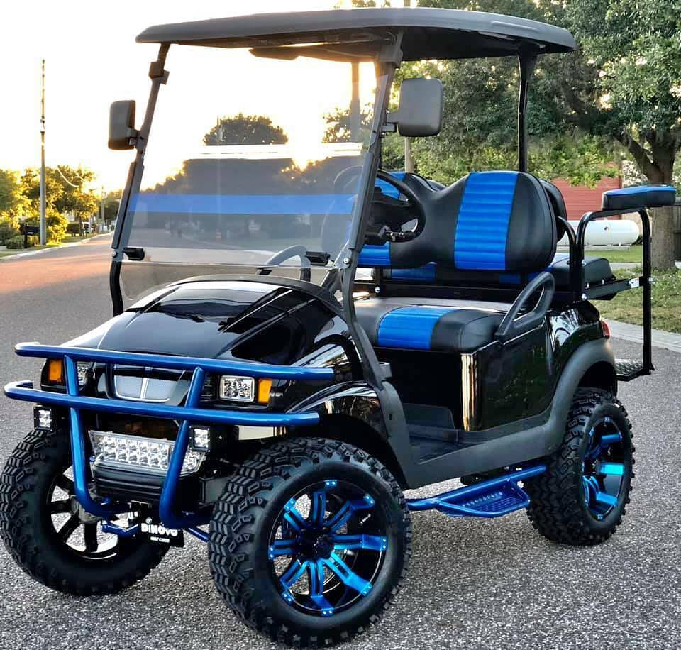  Advantages:  Lighter weight  More power  Advanced BMS  Aluminum IP67 case  Choice of waterproof chargers  8 year limited warranty |  |  |  |  |  |  | Aerolithium LLC .  Golf Cart LifePO4 Batteries  Lead time: 25 - 30 days  OEM/ODM service  Contact: Andy 850-844-8987  Email: sales@LITHIUMMOTO.com
Model | Technical Specification |  |  |  |  |  |  | Charge  Current | Discharge Current |  | General | Ex-Work
 | Nominal Voltage | Nominal Capacity | Stored Energy | Cycle Life | Dimension (LxWxH) | Weight | Typical mlieage per full charge | Standard Charge | Continuous Discharge | Maximum Discharge | Display & Bluetooth | Unit Price
36V Series
CP3654 | 36V | 54Ah | 2.08KWh | ＞4000  times | 440*336*243mm/  483*170*240mm | 27kg | 15-20 miles | 22A | 50A | 100A | Both | $call
CP36105 | 36V | 105Ah | 4KWh | ＞4000  times | 440*336*243mm | 34kg | 30-40 miles | 22A | 100A | 200A | Both | $call
51.2V Series
CP5154 | 51V | 54 Ah | 2.87 kWh | ＞4000  times | 416x334x232 mm/ 520x270x220mm | 73 lbs. (33kg) | 35-48 km(20-30 miles) | 22A | 50A | 200A (10S) | Both | $call
CP51105 |  | 105 Ah | 5.38 kWh |  | 472 x 334 x 243 mm | 95 lbs. (43.2kg) | 64-81 km(40-50 miles) |  | 150A | 315A (30S) | Both | $call
CP51105  P |  | 105 Ah | 5.38 kWh |  | 472x334x247 mm/ 565x330x255 mm | 103 lbs. (46.8kg) | 64-81 km(40-50 miles) |  | 300A | 600A (10S) | Both | $call
CP51160 | 51V | 160 Ah | 8.19 kWh |  | 827x330x232mm/ 800x360x232 mm | 165 lbs. (75kg) | 97-113 km(60-70 miles) |  | 150A | 315A (30S) | Both | $call
72V Series
CP72105 | 72 V | 105 Ah | 8.06 kWh | ＞4000  times | 740x320x245 mm | 149.5 lbs. (68kg) | 97-113 km(60-70 miles) | 18 A | 150A | 315A (30S) | Both | $call
CP72105 | 72 V | 160Ah | 11.77 kWh | ＞4000  times | 847x405x230mm/ 800x475x221 mm | 253 lbs. (115kg) | 97-113 km(60-70 miles) | 18 A | 150A | 315A (30S) | Both | $call

